Birla Institute of Technology & Science, Pilani
Work-Integrated Learning Programmes Division
First Semester 2019-2020
M.Tech (Data Science and Engineering)
Mid-Semester Test (EC-2 Regular)

Course No. : DSECL ZG555
Course Title : DATA VISUALIZATION & INTERPRETATION
Nature of Exam : Closed Book
No. of Pages = 4

No. of Questions = 9
Weightage : 30%
Duration : 90 Minutes
Date of Exam : 29/12//2019
Note:
- Please follow all the Instructions to Candidates given on the cover page of the answer book.
- All parts of a question should be answered consecutively. Each answer should start from a fresh page.
- Assumptions made if any, should be stated clearly at the beginning of your answer.

Answer All the Questions
(only in the pages mentioned against questions, if you need more pages, continue remaining answers from page 21)

Section 1 – Tableau Basics ( 2 +1+ 2 = 5 Marks)
[to be answered only in pages 3 -5]
1. | To connect to multiple tables in a single data source at one time, a join must be specified. What are the different types of join available in Tableau? | 2M
2. | Your view has the dimensions "Product Category," "Product Sub-category" and "Product Name." How would you combine these dimensions to enable drill down? Explain. | 1M
3. | What are Dashboard Actions in Tableau. Give any two methods by which you can run an action? | 2M

Section 2 – Data Visualization Concepts [4 + 1+ 2 + 6+2 = 15 Marks]
[to be answered only within pages 6-15]

4. | Briefly explain four Visualization Design Objectives. | 4M
5 | What do you mean by Visualisation Context? | 1M
6 | “Gestaltism” is the philosophy of how humans see/ perceive the world around us and extract patterns, derive conclusions from it. The Gestalt Principles of Visual Perception provide us a framework for explaining how human perception works. Using appropriate visuals, explain the difference between: Law of Enclosure and Law of Closure | 2M
7 | The following graph is found in the Sept 2003 issue DM Review. It is based on research conducted by Giga Research, a subsidiary of Forrester Research, Inc.  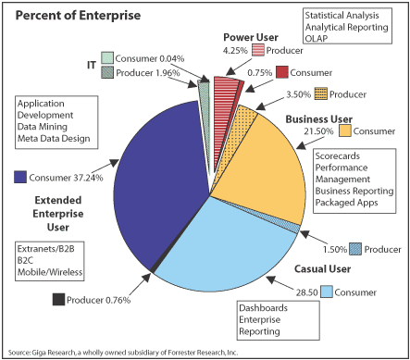  Redesign the above visualisation with appropriate choice of display medium to make it more effective. (Use the concepts learned in class). Present only the final version of the graph and list down the proposed changes and the reasons. | 6M
8. | If you needed to compare a lot of continuous variables would it be better to use a line graph or a scatter plot? Why? | 2M

Section 3 – Case Study [2.5 * 4 = 10 Marks]
[to be answered only within pages 16 to 20]

Below is the snapshot of a few metrics from the Sales data of a reputed organisation.You are expected to build informative charts (only textual + graphical representation and not a dashboard) ,using the metrics,which will help to answer the below questions. Wherever data not given,make assumptions.One is done for you.
Metric Name | Possible Values/Data Type
Customer Segment | Consumer
Customer Segment | Corporate
Customer Segment | Home Office
Customer Segment | Small Business
Customer Name | Categorical Value
Product Category | Furniture
Product Category | Office Supplies
Product Category | Technology
Product Name | Categorical Value
Region | Central
Region | East
Region | West
Region | South
State or Province | Categorical Value
Order Date  (Year/Month/Day) | 2010
Order Date  (Year/Month/Day) | 2011
Order Date  (Year/Month/Day) | 2012
Order Date  (Year/Month/Day) | 2013
Profit | Quantitative value
Sales | Quantitative value

Qn: Find the customer with the lowest overall profit. What is his/her profit ratio? Which display medium is used and why?
- Calculate Profit Ratio as SUM(Profit)/SUM(Sales).
- Create a horizontal bar chart between Customer name(Y Axis) and Profit(X Axis):
Bar charts are the best display medium for comparisons.Here we need to compare the profit of customer and pick the one with lowest profit.
- Sort the Bars based on Aggregate Profit(Ascending)
- Display the profit ratio next (the right end) to each bars.
- The customer belonging to the topmost bar will give the solution
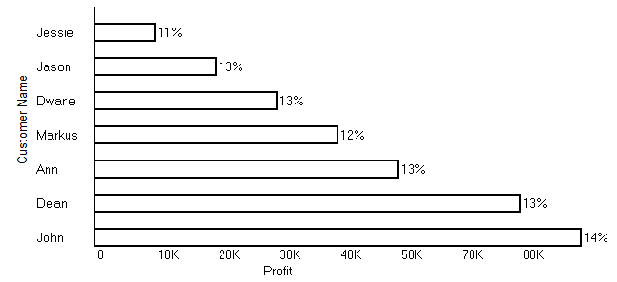
Now answer the below questions.
9.(a) | What was the Moving Average of Sales in June of 2012, including six months prior and six months after? Which display medium is used and why? | 2.5M
9.(b) | Find the top 10 Product Names by Sales within each region. Which product is ranked #2 in both the Central & West regions in 2011? Which display medium is used and why? | 2.5M
9.(c) | In the Technology Product Category, which unprofitable state is surrounded by only profitable states? Which display medium is used and why? | 2.5M
9.(d) | In which Region do all Product Categories fall beneath the overall average profit? Which display medium is used and why? | 2.5M

